**Instrument Selection Considerations**

The following is presented to help parents understand some of the considerations that need to be taken when fitting a child with an instrument.

**Physical Characteristics:** Lips, Teeth, Bite, Jaw Structure, and Hand Size

**Coordination Characteristics:** Hand Dominance, Visual Tracking, Hand-Eye Coordination, Hand-Foot Coordination, and Finger Dexterity

**Other Factors:** Personality, **DESIRE** (this ultimately conquers all)

**Woodwind Instruments**

|  |  |
| --- | --- |
|  |  |
| Flute | Oboe |
|  |  |
| Clarinet | Alto Saxophone |
| bassoon04 | |
| Bassoon | |

Woodwind players use all 10 fingers and both thumbs so finger dexterity is important. A child with any problem or difficulty in controlling and coordinating the fingers will not be happy playing a woodwind instrument. Holding a woodwind instrument is a matter of balance, therefore thumbs must be strong. Children with uncontrollable double-jointed fingers, especially thumbs, should avoid playing woodwinds.

The **FLUTE** is the soprano instrument of the woodwind family. A profile of a flute player would include medium full lips**, no tear-drop in the center of the lip**, a definite chin, and an agile tongue that is not attached too close to the tip. If the lower jaw either protrudes or recedes radically, the child would be better advised to select another instrument. Before the final decision is made, the child will be tested with the flute’s head joint in order to check for embouchure and the production of a good tone. Students who can say “pooh” with a pout and get a small slit between the lips may be very successful. Additionally, the flute uses a great deal of air!

The **OBOE** is a high double reed instrument. Oboists’ **upper lips must be fairly long**, capable of being folded over the teeth to grip the reed. An overbite is acceptable. Large gaps in the upper teeth may cause problems. Oboist’s teeth should be smooth, not jagged. People with short fingers or small hands may not be able to reach all of the keys or may find the stretch uncomfortable. Reeds are fragile and cost $10-$12 each. Oboe players should be patient individuals who enjoy doing things alone, and very determined individuals with a strong willpower to succeed. They must be bright academic students who can match a pitch well and have a good internal sense of pulse.

The **BASSOON** is a low double reed instrument. A slight overbite is a benefit for playing bassoon; an under bite is a major problem. Students need to be taller and have larger hands to span the reach of the keys. They need very good fine motor control since the fingerings are complex. They must be able to match pitch and have a good internal sense of pulse. Reeds are fragile and cost approximately $12 each. Bassoon players should be patient individuals who enjoy doing things alone, and very determined individuals with a strong willpower to succeed. Bassoon players must be bright academic students. Piano background is preferable but not a requirement.

The **CLARINET** student must be able to make and hold a firm chin (as when you say ‘Vee”). Lower teeth should not be jagged and a large overbite is a major problem. Sensitive teeth can make playing this instrument uncomfortable. **A thick lower lip will muffle the reed**. Children with even, **smooth perpendicular upper teeth** achieve greater success. Fingers must cover the open holes completely. Children with weak fine motor skills are easily frustrated with covering 5-6 holes.

The **SAXOPHONE** is built completely of brass. All saxophone players will start on alto saxophone. Children who wish to play the saxophone **should have large enough hands** to reach around the instrument, and work the keys without touching any of the side keys. The sax is a heavy instrument and, **since it hangs from the neck, the child must be** **fairly strong.** The saxophone imposes a burden on the little fingers and the sides of the index finger. Students with large hands can transfer easily to the tenor and baritone saxophone in middle school. Saxophones are more expensive than some of the other instruments in the band. For children who desire the personal expression of improvisation, sax is a good choice.

**Brass Instruments**

|  |  |
| --- | --- |
|  |  |
| **Trumpet** | **French Horn** |
|  |  |
| **Trombone** | **Baritone/Euphonium/Tuba** |

Brass instruments, those shiny powerful sounding instruments, appeal to a large number of children. A child who can sing or whistle a tune from memory can learn to play a brass instrument. Playing a brass instrument uses only 3 or 4 fingers of the right hand (except for French horn), unlike the woodwind instruments which require precise coordination of all ten fingers. Because brass playing can require physical strength and stamina, athletically inclined children often do well on these instruments. Lips must be free of scar tissue, and the size of the lips generally indicates the size of the instrument that is best suited to the child.

**TRUMPET** is the soprano voice for the brass family. Successful trumpet players are generally self-assured, outgoing individuals and will do well on this instrument. Good trumpet players’ **lips are usually fairly thin**. Children with excessive overbites may want to consider another instrument. Both fast and slow learners can do well on trumpet. The slower learners can be content playing the 2nd or 3rd parts, while the individuals who learn more quickly can build the technique demanded of 1st part players.

The **FRENCH HORN** is coiled so the bell faces back with the right hand in the bell. The rim size of the mouthpiece is similar to the trumpet, so individuals with thinner lips can be very successful with this instrument. However, many professional players have full lips and are successful. Students desiring to play the French horn need to have **a fine ear for pitch discrimination**. They are very determined individuals. This instrument is played with the left hand but this is not a factor for selection. Horn players must be bright academic students.

The **TROMBONE** is the only brass instrument that changes pitch by using a slide. Trombonists need good hand/eye coordination, and good pitch discrimination. A keen sense of pitch is vital because the trombonist must adjust the slide position, sometimes microscopically, to the correct note. Responsible, good-natured children make the best players**. A good sense of rhythm is a must. Students may have fuller lips. Size does not matter since some of my best trombone students were the smallest.**

The **EUPHONIUM** (or **BARITONE**) uses the same size mouthpiece as the trombone but has valves to change the pitch. **The size of the lips may be fuller.** Since the baritone is a little bigger than some of the other instruments, students should be strong enough to carry it to and from school if they walk. A student may play baritone all the way through 12th grade or switch to **TUBA** in middle or high school.

The **TUBA** is the largest instrument in the band, but the instruments used for beginners are ¾ size and easier to handle. Tuba players generally need to have fuller lips and a large lung capacity. While size of the student does not matter too much, a long torso (upper body) helps the student reach the mouthpiece of the tuba while resting the instrument on the front edge of their chair. Since the tuba is bigger than some of the other instruments, students should be strong enough to carry it to and from school if they walk. The tuba provides the musical foundation for the band. Tuba players are self-motivated and need to be independent players.

**PERCUSSION INSTRUMENTS**

**Percussionists must be physically coordinated, with especially good hand/eye coordination, and should have a steady, innate sense of pulse.** Understanding fractions in math is important to a percussionist. Beginners start on the snare drum and the bells. **Prior piano** **experience is helpful.** Students will be performing on three or four instruments early on in their study. **If your child gets fidgety from standing around, then percussion is not the instrument for them.** Justbecause your child beats on things in the house does not mean he/she will be a great drummer. (There are no drummers – they play all percussion instruments.)

**THE STRING INSTRUMENTS**

There are four kinds of stringed instruments in the orchestra: violins, violas, cellos, and double basses. All are made of wood and have a similar curvy shape, but their sizes are different. Violins, Violas and Cellos are offered to 5th graders. Students interested in bass should choose cello in 5th grade and switch to bass in 6th grade.

All stringed instruments have strings stretched over them. The strings are made of gut, steel, or nylon. They are played with a bow or by plucking the strings with the fingers.

The **VIOLIN** is the soprano voice in the string family. It is held under the chin, resting on the shoulder. The violin has a lovely tone that can be soft and expressive, exciting and brilliant.

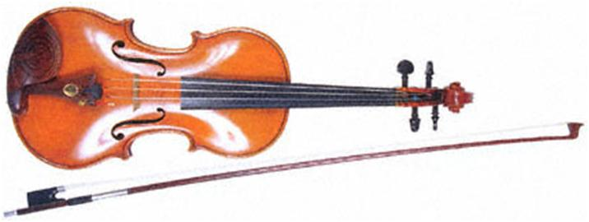

The **viola** is the alto voice in the string family. Like the violin, it is held under the chin, resting on the shoulder. Unlike the violin, the viola is slightly larger and is tuned five notes lower. It has a darker and warmer tone quality than the violin.

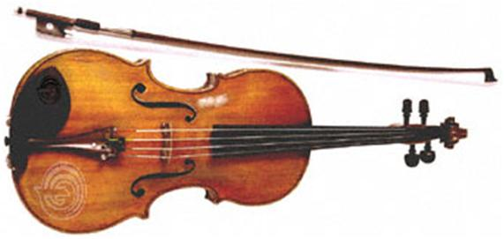

**The violoncello** or **cello** is the tenor voice in the string family. While shaped like a violin, the cello is much larger and is held between the player’s knees. Because it can produce beautiful sounds from its lowest to its highest notes, it is a popular instrument.

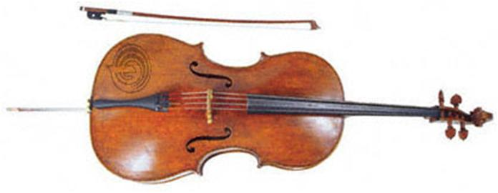

The **double bass** or string bass is the largest and lowest instrument of the string family. The double bass has rounded shoulders instead of square shoulders like the other string instruments. Because of its size, the player stands or sits on a high stool to play it. This instrument is available in 6th grade.

